Real-Time Age and Gender Prediction Using Deep Learning and OpenCV

A Project Work
Submitted in Partial fulfillment for the award of

Graduate Degree of Bachelor of Technology (B. Tech)
In
Computer Science & Engineering
(Session: 2021-25)

Submitted By

Yashvant Bairagi

Enroll No: 0223CS211062

Under the Guidance of

Mr. SYED MANZOOR ALI SIR

(head of department)
(Computer Science & Engineering)

DEPARTMENT OF COMPUTER SCIENCE & ENGINEERING SAINT ALOYSIUS INSTITUTE OF TECHNOLOGY JABALPUR (M.P.)

Rajeev Gandhi proudyogiki Vishwavidyalaya, Bhopal (M.P.)
DEPARTMENT OF COMPUTER SCIENCE & ENGINEERING
SAINT ALOYSIUS INSTITUTE OF TECHNOLOGY JABALPUR (M.P.)

CERTIFICATE

This is to certify that

Yashvant Bairagi (Roll no-0223CS211062)

students of 8th semester, Computer Science & Engineering S.A.I.T., Jabalpur have duly completed their final year project entitled “Real-Time Age and Gender Prediction Using Deep Learning and Open CV” for the partial fulfillment of the requirement for the degree of Bachelor of Technology as per R.G.P.V. Bhopal.

They have successfully implemented and tested this project, which meets all the requirements specified under my guidance.

Prof. Syed Manzoor Ali  (H.O.D.)  Computer Science and Engineering Dept.  SAIT, Jabalpur |  | Dr. Smita Shrivastava  (Principal)  SAIT, Jabalpur

Rajeev Gandhi Proudyogiki Vishwavidyalaya, Bhopal (M.P.)
DEPARTMENT OF COMPUTER SCIENCE & ENGINEERING
SAINT ALOYSIUS INSTITUTE OF TECHNOLOGY JABALPUR (M.P.)

CERTIFICATE

This is to certify that

Yashvant Bairagi(Roll no-0223CS211062)

students of 8th semester, Computer Sc. & Engg. S.A.I.T., Jabalpur have duly completed their final year project entitled “Real-Time Age and Gender Prediction Using Deep Learning and OpenCV” for the partial fulfillment of the requirement for the degree of Bachelor of Technology as per R.G.P.V. Bhopal.

They have successfully implemented and tested this project, which meets all the requirements specified under my guidance.

INTERNAL EXAMINER EXTERNAL EXAMINER

Date: Date:
PREFACE

This project report is a part of the curriculum for the 8th Semester of Bachelor of Technology in Computer Science. The project titled “Real-Time Age and Gender Prediction Using Deep Learning and OpenCV” has been developed using the deep learning AI based technology (python programming Language, Django framework, open cv, face detection algorithm and open CV).

Age and gender detection using OpenCV in Python involves employing pre-trained deep learning models to analyze facial images. The process typically begins with face detection, followed by feeding the detected face region into separate models for age and gender classification. These models output predicted age ranges and gender labels. OpenCV provides the necessary tools for image processing and model loading, making it a practical solution for real-time applications.
ACKNOWLEDGEMENT

We take this opportunity to express our deepest gratitude to everyone who has helped us in the successful completion of our project. We extend our sincere thanks to our internal guide, faculty members, and the department for their continuous support, guidance, and encouragement.

We also thank our external mentor for providing real-world insights and valuable feedback throughout the project. Lastly, we are grateful to our peers and family for their moral support.
DECLARATION

We hereby declare that the project entitled “Real-Time Age and Gender Prediction Using Deep Learning and OpenCV” submitted in partial fulfillment of the requirement for the degree of Bachelor of Technology in Computer Science is the outcome of our own work and the results presented in this report have not been submitted to any other University or Institution for the award of any degree or diploma.

Index

S. No. | Topic | Page No.
1 | Introduction | 1–2
2 | Analysis
  3–8
3 | Design | 8–11
4 | Tools Used
  12-14
5 | Coding | 14–15
6 | Testing | 16–18
7 | Output | 19
8 | SWOT Analysis | 20
9 | Conclusion | 21
10 | Reference | 22

INTRODUCTION

Biometrics, is the science of analyzing the physical or behavioral characteristics of each individual that enable the authentication of their identity in a reliable manner, it offers significant advantages conventional identification methods, such as passwords and cards, are not transferable, exclusive to each person and are not lost or stolen, particularly because of biometric features.

The range of biometric solutions relies on user approval, security, cost and time for implementation...etc. Recently, face recognition has been one of the most interesting tasks in pattern recognition, many applications use this technique because the human face is considered a very rich source of information.

In particular, gender and age are facial features that can be very useful for a multitude of applications, for example an automatic gender and age prediction system is used to profile customers who are interested for a product or for target advertising. The areas of age and gender classification have been studied for decades.

Until detailing the methods used in this article, we will first provide a summary of the facial recognition experiments carried out by scholars, which can be grouped into tree classes of interest.

Over the last decade, the rate of image uploads to the Internet has grown at a nearly exponential rate. This newfound wealth of data has empowered computer scientists to tackle problems in computer vision that were previously either irrelevant or intractable. Consequently, we have witnessed the dawn of highly accurate and efficient facial detection frameworks that leverage convolutional neural networks under the hood.

One of the most critical barriers that face any system to age estimation or age-classification is the absence of a consistent pattern of facial aging.

This is due to the nature of human faces, and the stages of aging may differ from one human to another.
Analysis

Objective of the Project

The primary objective of this project is to develop a system that can automatically detect human faces from a live webcam feed and accurately predict their age and gender using deep learning techniques.

This real-time detection system can be used in areas such as demographic analysis, smart surveillance, targeted advertising, and human-computer interaction.

- Face Detection:

Implement a robust face detection mechanism using Haar cascades or deep learning-based models to accurately locate faces within an image or video frame, which is essential for subsequent age and gender classification.

- Age Classification:

Develop a model to categorize detected faces into predefined age ranges, rather than predicting an exact age, which is more practical due to the subjective nature of age appearance.

- Gender Classification:

Train a model to classify detected faces as either male or female, using features extracted from the facial region, which can be achieved through various machine learning or deep learning techniques.

- Integration with OpenCV:

Seamlessly integrate face detection, age classification, and gender classification models using OpenCV, which is a powerful library for image processing and computer vision tasks.

- Real-Time Processing:

Optimize the code to enable real-time processing of video streams, allowing for the continuous detection of age and gender, which is crucial for interactive applications or video analysis.

Requirement Gathering

The requirement gathering phase focuses on understanding what the system is expected to do. The key requirements include:
- Detecting human faces from a live webcam feed.
- Predicting the age group (e.g., 0-2, 4-6, 8-12, etc.) of the person.
- Predicting the gender (male/female).
- Providing real-time feedback with accuracy and efficiency.
- A simple user interface or command-line-based system.

Hardware Requirements

- Laptop or desktop with:

  - Minimum 4 GB RAM (8 GB recommended)
  - Intel i3 processor or better
  - Integrated or external webcam
  - At least 5 GB free disk space

Software Requirements

- Operating System: Windows/Linux/MacOS
- Python 3.x
- Python Libraries: OpenCV, NumPy
- Deep Learning Framework: OpenCV DNN or TensorFlow/Keras (if using custom models)
- Pre-trained Caffe models for age and gender prediction
- Jupyter Notebook (optional for development and testing)

Browser:

Google Chrome or Firefox

Feasibility Study

- Technical Feasibility: Technically feasible as Python and OpenCV provide mature libraries for real-time image processing. Pre-trained models are readily available.

- Operational Feasibility: The system is simple to operate and requires minimal user interaction, making it feasible for general use.

- Economic Feasibility: Cost-effective since it uses open-source libraries and existing hardware (webcam/laptop).

Software Model

- The Waterfall Model is used for this project. Each phase—requirements, design, implementation, testing, deployment, and maintenance—follows a sequential approach. This is suitable for a small-to-medium size project with clear objectives and scope.

- The waterfall model is a Software Development Model used in the context of large, complex projects, typically in the field of information technology. It is characterized by a structured, sequential approach to Project Management and Software Development.

- The Waterfall Model is useful in situations where the project requirements are well-defined and the project goals are clear. It is often used for large-scale projects with long timelines, where there is little room for error and the project stakeholders need to have a high level of confidence in the outcome.

Software Development Life Cycle (SDLC)

Definition:

SDLC is a process followed for software building within a software organization. SDLC consists of a precise plan that describes how to develop, maintain, replace, and enhance specific software. The life cycle defines a method for improving the quality of software and the all-around development process.

Stages of the Software Development Life Cycle:

- Requirement Analysis: Identifying the functionalities (face detection, age & gender prediction).

- System Design: Planning the architecture and choosing suitable models.

- Implementation: Coding using Python, integrating OpenCV and DNN models.

- Testing: Verifying real-time predictions and checking model accuracy.

- Deployment: Running the application on the local system.
- Maintenance: Making adjustments based on performance or feedback.

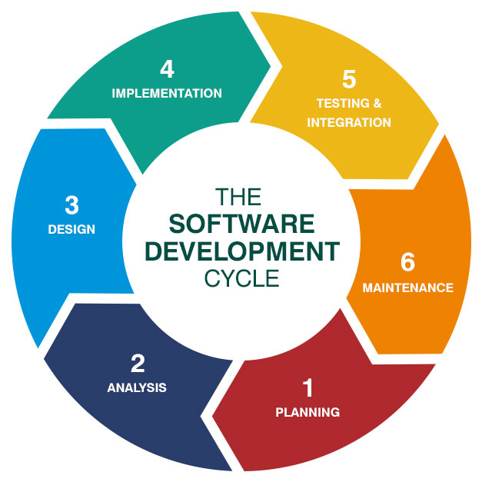

Cost Estimation

Since open-source tools are used, the overall cost is minimal:

- Software: RS. 0 (open-source)

- Hardware: Already available in most environments

- Development Time: ~20-30 hours (approx.)

- Total Estimated Cost: Minimal to zero (using existing resources)

- Development Cost: NIL (self-developed using open-source tools)

- Tool Cost: NIL (VS Code, MongoDB Compass, Postman – all free)

DESIGN

Input requirements

1. Hardware Input
- Webcam (Integrated or External)
Used to capture live video frames of human faces in real time.

2. Software Input
- Live Video Feed
Continuous stream of images from the webcam to process and detect faces.

- Pre-trained Deep Learning Models

  - age_net.caffemodeland deploy_age.prototxt.

  - gender_net.caffemodel and deploy_gender.prototxt
These are the deep learning models used to predict age and gender.

- Face Detection Model

  - Haar Cascade or DNN face detector (deploy.prototxt and res10_300x300_ssd_iter_140000.caffemodel)
Used to detect face.

  - in the video frames before passing them to the age/gender model.

3. Python Script Input

- The script requires:

  - Access to webcam (cv2.VideoCapture(0))

  - Loaded models (Caffe/TensorFlow)

  - Proper pre-processing of face images (resizing, normalization)

Design of database

For a basic Age and Gender Detection project using OpenCV and pre-trained deep learning models, a database is not required.
Because:

- Uses a live webcam feed
- Predicts age and gender in real-time
- Does not store user data, logs, or history

Database could be useful:

- I want to store prediction results (e.g., name, age, gender, timestamp)

- I AM tracking multiple users over time

- I want to create a user profile system (like in a smart attendance or access control system)
- I integrating with other systems (e.g., CRM, demographics dashboard)

In that case, you can use:

- SQLite (lightweight, local)

- MySQL / PostgreSQL (for larger apps)

- MongoDB (if you prefer NoSQL)

Activity-DIAGRAM

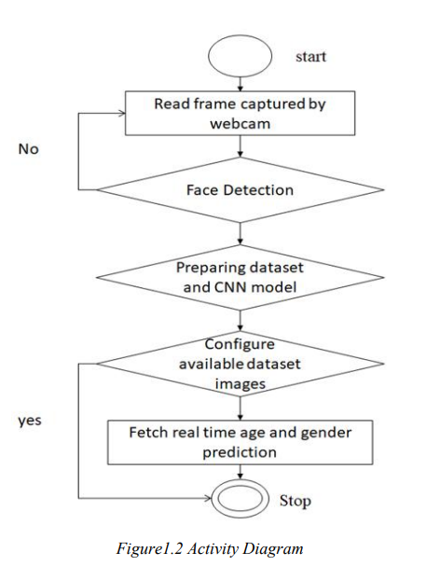
DATA -FLOW- DIAGRAM

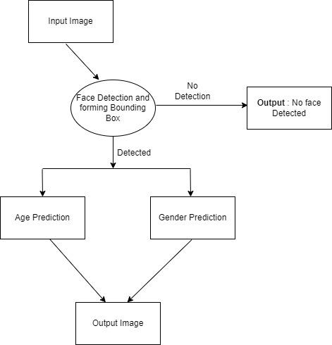

TOOLS USED

Programming Language

- Python 3.x
(Main language used for coding the project.)

Libraries and Frameworks

• OpenCV (cv2)
(For image processing, face detection, accessing the webcam, and handling video frames.)

• NumPy
(For numerical operations like array manipulations.)

• OpenCV DNN Module
(For loading and running pre-trained deep learning models for age and gender prediction.)

Pre-trained Deep Learning Models

• Age Detection Model
(age_net.caffemodel, deploy_age.prototxt)

• Gender Detection Model
(gender_net.caffemodel, deploy_gender.prototxt)

• Face Detection Model (res10_300x300_ssd_iter_140000.caffemodel, deploy.prototx

Development Environment

• Jupyter Notebook (optional, for testing and developing scripts)

• VS Code / PyCharm (for writing and managing Python code)

Hardware requirement

• Webcam (integrated or external, to capture live video)

• Laptop/Desktop with moderate specs (4 GB RAM minimum)

Operating System

- Windows / Linux / macOS
(Any platform where Python and OpenCV are supported.

Table of tools used

Category | Tool/Technology | Purpose
Programming Language | Python 3.x | Core language for development
Library | OpenCV (cv2) | Image processing, webcam handling
Library | NumPy | Numerical operations and array management
Deep Learning Module | OpenCV DNN | Loading and running pre-trained models
Pre-trained Models | Caffe Models (.caffemodel, .prototxt) | Age, gender, and face detection
Development Environment | Jupyter Notebook / VS Code / PyCharm | Writing and testing Python code
Hardware | Webcam | Capturing live images and video frames
Hardware | Laptop/Desktop (4 GB RAM minimum) | Running the software
Operating System | Windows / Linux / macOS | Platform support for Python and OpenCV

Pretrained deep learning models used

Model Name | File Names | Purpose
Age Detection Model | age_net.caffemodel, deploy_age.prototxt | Predicting age group of a face
Gender Detection Model | gender_net.caffemodel, deploy_gender.prototxt | Predicting gender (Male/Female)
Face Detection Model (SSD ResNet10) | res10_300x300_ssd_iter_140000.caffemodel, deploy.prototxt | Detecting and locating faces

CODING

"The following screenshots show the Python code implemented for Age and Gender Detection using OpenCV and Deep Learning. The code includes importing necessary libraries, loading pre-trained models, capturing video from the webcam, detecting faces in real-time, and predicting the age and gender of the detected faces. The results are displayed directly on the live video feed with bounding boxes and labels."

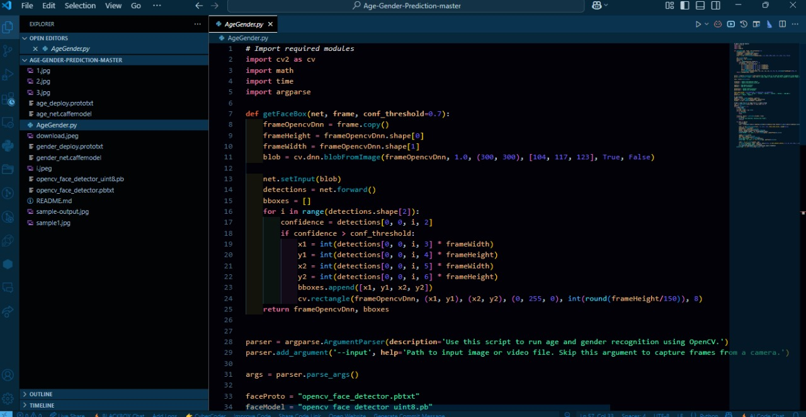

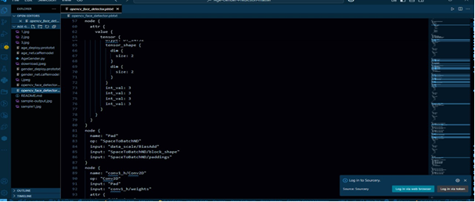

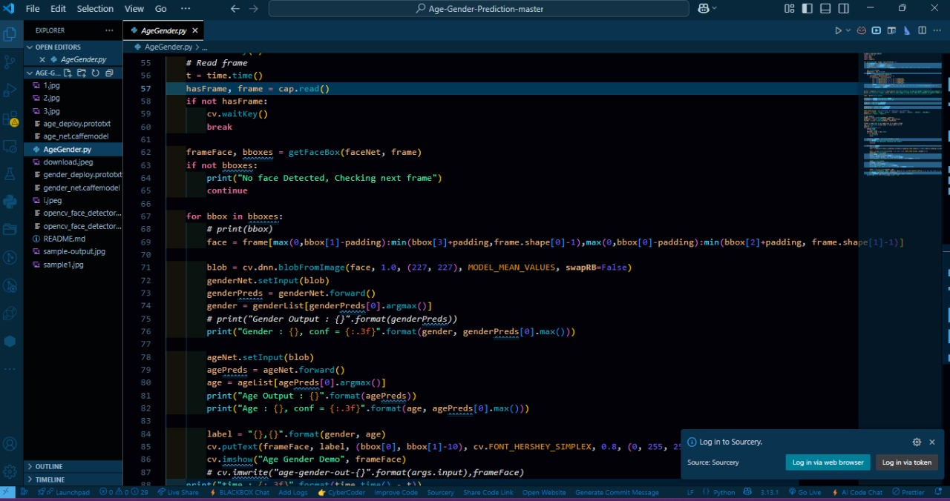
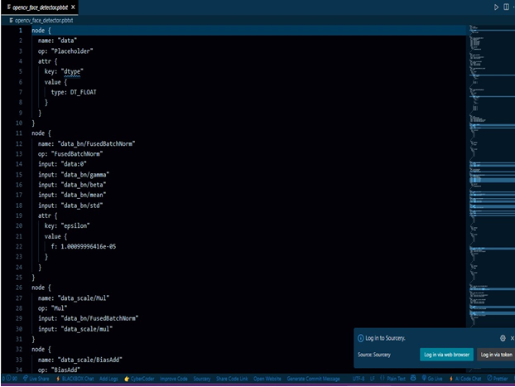
Output
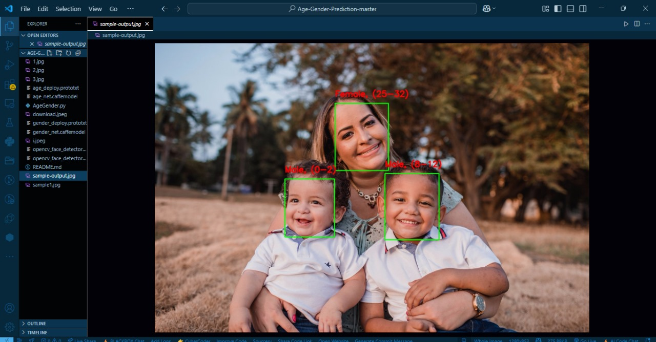
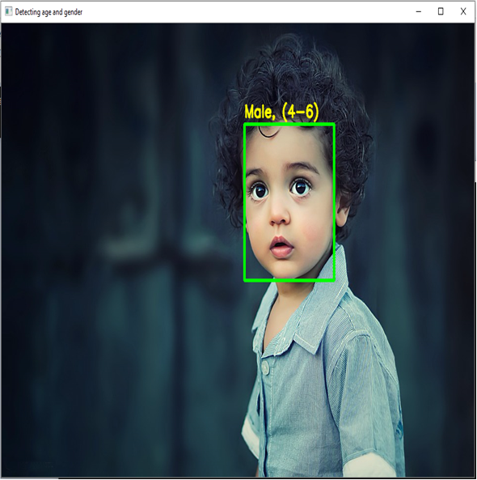

TESTING
1. Objective of Testing
The main objective of testing is to verify that the system accurately detects faces and correctly predicts the age group and gender in real-time using webcam input. Testing ensures that the models are loaded properly, the face detection is accurate, and the predictions are displayed without significant delay.

2. Testing Approach
- Unit Testing:
  - Individual components such as model loading, face detection, and prediction functions were tested separately.

- Integration Testing:
  - All modules were integrated and tested together to ensure smooth video capture, real-time detection, and prediction without system crashes.

- System Testing
  - The complete system was tested using different users with varying age groups and genders to validate prediction accuracy.

3. Test Cases
Test Case | Input | Expected Output | Result
Model Loading | Pre-trained model files | Models load successfully | Passed
Webcam Access | Live video feed | Video frames captured in real-time | Passed
Face Detection | Face in webcam frame | Face detected and highlighted | Passed
Age Prediction | Detected face | Correct age group prediction displayed | Passed (minor errors on edge cases)
Gender Prediction | Detected face | Correct gender prediction displayed | Passed
Display on Frame | Prediction result and bounding box | Clear and real-time display | Passed

4. Observations
- Face Detection works accurately even with multiple faces in the frame.

- Age and Gender Predictions are reasonably accurate, but slight inaccuracies may occur for borderline age groups.

- Performance is real-time with minimal lag on systems with at least 4 GB RAM.

- Lighting Conditions can affect detection and prediction accuracy slightly.

CONCLUSION
The project "Age and Gender Detection Using OpenCV and Deep Learning in Python" successfully demonstrates the real-time prediction of a person’s age group and gender by capturing live images through a webcam. By utilizing pre-trained deep learning models and open-source libraries like OpenCV and NumPy, the system provides quick and fairly accurate results.
Despite minor limitations due to lighting conditions or model constraints, the application works efficiently under normal scenarios. This project highlights the potential of computer vision and deep learning in building intelligent systems and can be extended further for applications in security, marketing analytics, healthcare, and smart surveillance systems.

Thus, the project has been successfully completed, meeting the objectives and achieving the desired outcomes.
We can apply the Age and Gender Detection using OpenCV and Deep Learning project across multiple real-time applications and industries. Some examples include:
- Smart Advertising – Displays personalized advertisements based on detected age and gender.
- Retail Analytics – Helps businesses understand customer demographics to improve marketing strategies.
- Security Systems – Enhances surveillance by monitoring demographic patterns in real-time.
- Access Control – Provides secure entry by automatically verifying age and gender.
- Healthcare Monitoring – Assists hospitals in quickly categorizing patients based on their age groups.

Reference
- OpenCV Documentation
(https://docs.opencv.org/)

- OpenCV DNN Module Tutorials
(https://docs.opencv.org/master/d6/d0f/group__dnn.html)

- NumPy Documentation
(https://numpy.org/doc/)

- Caffe Pre-trained Models for Age and Gender Detection
(https://github.com/spmallick/learnopencv/tree/master/AgeGender)

- Python Official Documentation
(https://docs.python.org/3/)

- Research Paper: "Deep Learning for Age and Gender Classification"
(https://arxiv.org/abs/1611.07004)

- TutorialsPoint - OpenCV with Python Guide
(https://www.tutorialspoint.com/opencv/index.htm)

